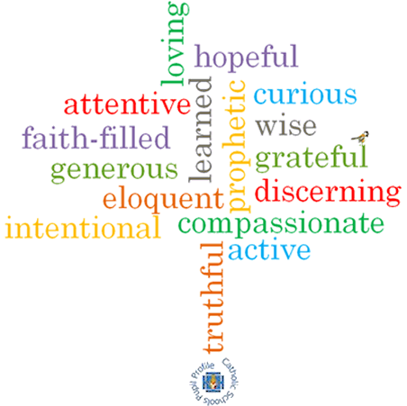

**Strand: Advent/Christmas**

**ving**

**Phase: LKS2**

**Topic: Gift**

**Come and See Knowledge Organiser**

**What should I already know?**

Advent is a time of waiting for the coming of Jesus.

**Big Questions**

Why are the gifts of love and friendship important?

What are the joys and demands of the commitment

required in the gift of love and friendship?

**Vocabulary I will need to use**

|  |  |
| --- | --- |
| gift | A present |
| friendship | The relationship between friends |
| loyalty | The quality f being loyal. |
| commitment | To be dedicated to something. |
| rejoice | To feel or show great joy or delight. |
| peace | Freedom from disturbance. A feeling of tranquillity. |
| God’s plan | The plan God has for each one of us. |

**What I will learn**

**Ask and respond** to questions about what is important in friendship.

A**sk questions** about what they and others wonder about the gift of love and friendship.

**Retell** the story of the birth of Jesus and the visit of the Wise Men.

Use religious words and phrases to **describe** some of the religious actions and symbols which help Christians prepare during Advent for the coming of Jesus at Christmas.

**Make links** to show how feelings and beliefs affect their behaviour and that of others in relation to the gift of love and friendship.

**Begin to compare** their own and other people’s ideas about the gift of love and friendship.

**Make links** between scripture texts and the belief that God sent Jesus to earth as the long-awaited Messiah.

**Use** a developing religious vocabularyto **give reasons** for the actions and symbols connected with the liturgical season of Advent and Christmas.

**Virtues**

**Scripture I will hear:**

Isaiah 40: 9-11

Matthew 2: 1-12, 16-18

Ephesians 1: 3-6

1 John 4: 4, 9-12

Philippians 4: 4-9