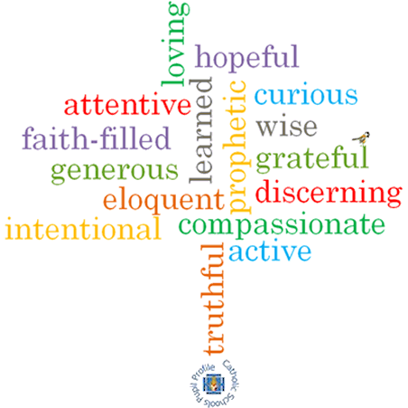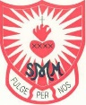

**Topic: God’s People**

**Strand: Universal Church**

**Phase: LKS2**

**Come and See Knowledge Organiser**

**What should I already know?**

About special places in the world for Jesus and the Christian community.

**Big Questions**

Why do some people do extraordinary things?

**Vocabulary I will need to use**

|  |  |
| --- | --- |
| Ordinary | With no special or distinctive features, normal. |
| Extraordinary | Very unusual or remarkable |
| Admire | Regard with respect or warm approval. |
| Saint | A person acknowledged as holy or virtuous and is formally recognised after their death. |
| Martyr | A person who is killed because of their religious or other beliefs. |
| Communion of Saints | The spiritual union of members of the Christian Church, living and dead. |
| Peace | Freedom from disturbance, tranquillity |
| justice | Just behaviour or treatment. |

**What I will learn**

**Ask and respond** to questions about their own and others’ experiences and feelings of ordinary people doing extraordinary things and be able to **ask questions** about what they and others wonder about ordinary people doing extraordinary things.

**Retell** some special stories about religious events and people who show what God is like and will be able to **describe** some ways in which religion is lived out by different saints.

**Give reasons** for certain actions by those people they have studied and be able to **make links** between Scripture and the action and beliefs of followers of God’s way.

**Make links** to show how feelings and beliefs affect their behaviour and that of others, using the example of Eric or other examples and **compare** their own and other people’s ideas about the question of what makes a person do extraordinary things.

**Show how** their own and others’ decisions about actions in life are informed by beliefs and values and **describe and show** an understanding of Scripture, beliefs, ideas, feelings and experience, making links between them.

**Show understanding** of how religious belief has shaped the way some people live out their lives.

**Virtues**

**Scripture I will hear:**