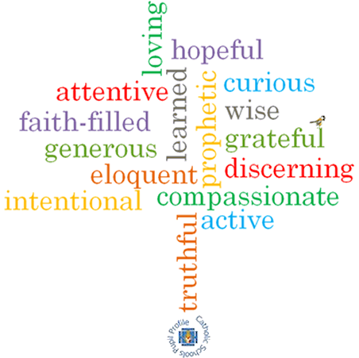

**Strand: Domestic Church**

**Phase: UKS2**

**Topic: Ourselves**

**Come and See Knowledge Organiser**

**What should I already know?**

The family of God in Scripture

**Big Questions**

Who am I?

What makes me unique?

Where do I come from?

**Vocabulary I will need to use**

|  |  |
| --- | --- |
| Qualities | a distinctive attribute or characteristic possessed by someone or something. |
| Unique | being the only one of its kind; unlike anything else. |
| Gifts | a natural ability or talent. |
| Challenge | a call to prove or justify something. |
| Joys | a feeling of great pleasure and happiness. |
| Responsibility | having a duty to deal with something or of having control over someone. |
| Dignity | a composed or serious manner or style. |
| Image | he general impression that a person presents to the public. |
| Talents | natural aptitude or skill. |
| happiness | the feeling of being happy |
| peacemaker | a person who brings about peace |

**Scripture I will hear:**

Genesis 1: 26 –28

Colossians 3: 10 -11

Colossians 3: 12-17

Philippians 4: 4-9

Hosea 11: 1-4 –

**What I will learn**

**Make links** between their beliefs about talents and qualities and how they use them and how it affects others.

**Compare** their own and other people’s ideas about questions of talents and qualities.

**Make links** between the words of Paul and the Christian’s belief in peace.

**Give reasons** why Christians believe in peace.

**Begin to** **show understanding** of howbeliefs and values affect our love and care of each other.

**Describe** and **show an understanding** of the scripture, beliefs, feelings and the experience of being made in image and likeness of God.

**Begin to show understanding** of how the call to be holy shapes life

**Virtues**