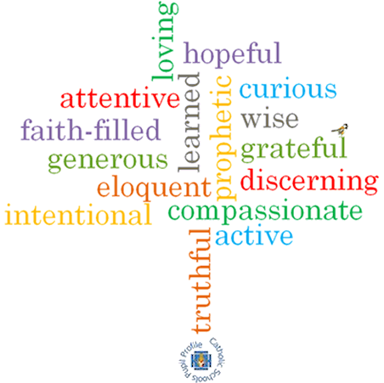

**Topic: Sacrifice**

**Strand: Lent/Easter**

**Phase: UKS2**

**Come and See Knowledge Organiser**

**What should I already know?**

Celebrating growth to new life

**Big Questions**

Why are some people so generous in their giving?

What does sacrifice mean in daily life?

Why do we sometimes refuse to give?

**Vocabulary I will need to use**

|  |  |
| --- | --- |
| Giving | freely set aside or devote for a purpose |
| Temptation | the desire to do something, especially something wrong or unwise |
| Betrayal | the action of betraying a group, or person |
| Self-sacrifice | the giving up of ones own interests or wishes, in order to help others or advance a cause |
| Gethsemane | the garden outside of Jerusalem mentioned in Mark 14 as the scene of the agony and arrest of Jesus |
| Crucifixion | the death of Jesus upon the cross |
| Resurrection | the act of rising from the dead |
| carer |  |
| cost |  |
| Holy Week |  |
| Maundy Thursday |  |
| Altar of Repose |  |
| love |  |
| Easter vigil |  |

**Scripture I will hear:**

Matthew 26: 14-16, 25, 38-48, 47-50

Matthew 28: 1-10

Mark 14: 10-11, 32-36, 43-46

Mark 15: 1-15,

Mark 15: 21-41

Luke 4: 1-12

Luke 22:39-46

Luke 23: 26-43

John13: 34-35,

John 20: 1-10

**What I will learn**

**Make links** to show how feeling and beliefs affect giving and refusing to give and appreciating the cost of giving.

**Compare** their own and other people’s ideas about questions concerning giving and refusing to give and appreciating the cost of giving and realise that these questions are difficult to answer.

**Make links** between the scripture stories of Holy Week and the Temptation in the desert and how Christians observe the season of Lent.

Use a developing religious vocabularyto **give reasons** for religious actions and symbols used during Holy Week and the Easter Vigil.

**Give reasons** whyChristians make sacrifices during Lent.

**Show how** their own and others’ decisions about giving and refusing to give are informed by beliefs and values.

**Describe and show understanding** of a range of scripture stories, beliefs, ideas and feelings about the sacrifice of Jesus and his resurrection and make links between them.

Use religious terms to **show an** **understanding** of the different liturgies of Holy Week and the Easter Vigil.

**Show understanding** of how belief in the sacrifice Jesus made, and belief in the Resurrection shapes lives.

**Engage with and respond** to questions about sacrifice in the light of religious teaching.

**Virtues**