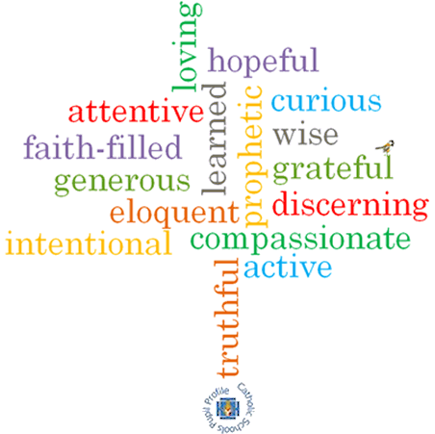

**Strand: Baptism/Confirmation**

**Phase: UKS2**

**Topic: Life Choices**

**Come and See Knowledge Organiser**

**What should I already know?**

Confirmation: a call to witness

**Big Questions**

What is important for friendship to thrive?

Why are fidelity and commitment important in relationships?

**Vocabulary I will need to use**

|  |  |
| --- | --- |
| Vocation | a strong feeling of suitability for a particular career or occupation. |
| Marriage | the legally or formally recognized union of two people as partners in a personal relationship |
| Service | the action of helping or doing work for someone. |
| Responsibility | the state or fact of having a duty to deal with something or of having control over someone. |
| Fidelity | faithfulness to a person, cause, or belief, demonstrated by continuing loyalty and support. |
| Commitment | the state or quality of being dedicated to a cause, activity, etc |
|  |  |
|  |  |

**Scripture I will hear:**

Ephesians 4: 1-7

Ephesians 4: 11-13, 15

Proverbs 31: 10-29

Matthew 5: 6-9

**What I will learn**

**Make links** to show how feelings and beliefs affect their own and others’ quality of care and commitment towards each other.

**Make links** to show how feelings and beliefs affect their own and others’ behaviour in relationships.

Use a **developing religious vocabulary** to **give reasons** for the religious actions and symbols used in the Sacrament of Marriage.

**Give reasons** for the love and service shown by Christians.

**Make links** to show how feelings and beliefs affect their behaviour and that of others, concerning their mission in life.

**Begin to compare** their own and other people’s ideas about questions concerning care and commitment that are difficult to answer.

**Begin to engage with** and respond to questions of life, particularly in relationships.

**Begin to** **describe and show understanding** of religious sources, beliefs, ideas, feelings and experiences making links between them; concerning the mission of a Christian and married people in particular.

**Use religious terms** to **begin to show an understanding** of the marriage liturgy and the Promises made.

**Begin to show understanding** of how religious belief shapes the lives of married people.

**Begin to show understanding** of how religious belief shapes the lives of those who are involved in the community as volunteers.

**Virtues**