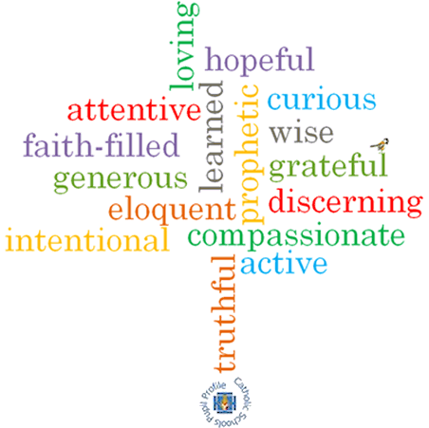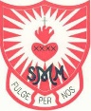

**Topic: Memorial Sacrifice**

**Strand: Eucharist**

**Phase: UKS2**

**Come and See Knowledge Organiser**

**What should I already know?**

The Eucharist challenges and enables living and growing in communion

**Big Questions**

Why do some things evoke memories?

Why are memories important?

How is it possible to keep important memories alive?

**Vocabulary I will need to use**

|  |  |
| --- | --- |
| Memories | something remembered from the past |
| Passover | major Jewish festival which celebrates the liberation of the Israelites from Egyptian slavery |
| Host | a portion of bread used for Holy Communion in many Christian churches |
| Chalice | the wine goblet used in the Christian Eucharist |
| Consecration | the action of declaring bread and wine to be, or represent, the body and blood of Christ |
| Genuflect | bending one knee to the ground, typically in worship |
| significant |  |
| memorial sacrifice |  |
| Pesach |  |
| liturgy of the Eucharist |  |
| Eucharistic Prayer |  |
| adoration |  |
| acclamation |  |

**Scripture I will hear:**

Exodus 13: 3

Luke 22: 14-20

**What I will learn**

**Compare** their own and others’ ideas about what makes a particular memory significant and why words, symbols or actions might evoke it and realise these questions are difficult to answer.

**Make links** to show how feelings and beliefs about memories affect their own behaviour and that of others.

**Make links** between the Passover in Exodus, the Last Supper and belief in the Eucharist.

Use a developing religious vocabularyto **give reasons** for religious actions and symbols connected to the Passover and the celebration of the Eucharist.

**Give reasons** for why believers follow the example of Jesus in his life of sacrifice.

**Show understanding** of howtheir own and others’ decisions about memories are informed by beliefs and values.

**Describe and show understanding** of scripture, beliefs, ideas, feelings and experiences about the Jewish Passover, the Last Supper and the celebration of Eucharist, making links between them.

**Show understanding** of how belief in the sacrifice of Jesus shapes the lives of Christians.

**Engage** with and **respond** to questions of life choices in the light of religious teaching about sacrifice.

**Virtues**