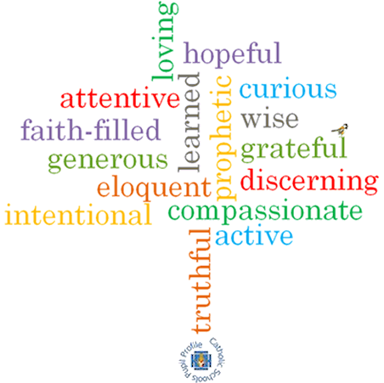

**Strand: Advent/Christmas**

**Phase: UKS2**

**Topic: Hope**

**Come and See Knowledge Organiser**

**What should I already know?**

Advent and Christmas: The Church’s seasons of preparing to receive God’s gift of love and friendship in Jesus

**Big Questions**

What is the hidden meaning in waiting?

What is the difference between hope and expect?

**Vocabulary I will need to use**

|  |  |
| --- | --- |
| Waiting | the action of staying where one is or delaying action until a particular time or event. |
| Hopeful | feeling or inspiring optimism about a future event. |
| Promised One | A phrase used to describe someone very special sent to us. |
| Messiah | the promised deliverer of the Jewish nation prophesied in the Hebrew Bible. |
| Prophet | a person regarded as an inspired teacher or proclaimer of the will of God. |
| Advent | means ‘coming.’ Advent is the four weeks before Christmas, when we get ready for Jesus’ birthday. |
| Jesus the promised one | Isaiah promised that God would send a wise and just leader for his people. |
| Advent wreath | The wreath is made of various evergreens, signifying continuous life. Holly also has a special Christian symbolism: The prickly leaves remind us of the crown of thorns, worn by Jesus. The circle of the wreath, which has no beginning or end, symbolizes the eternity of God and the everlasting life found in Christ. |
| Joyful Mysteries of the Rosary | The Joyful Mysteries are taken mostly from St. Luke's Gospel in the New Testament. They involve the joyful events of Jesus' childhood. |

,

**Scripture I will hear:**

Psalm 27: 13-14,

I Samuel 16: 4-13

Isaiah 9: 2-3, 6-7, Isaiah 25: 8-9, Isaiah 40: 9-11

Jeremiah 33:14-16,

John 1: 5 Matthew 1:1-17

Matthew 1:18-25,

Mark 13:33

Luke 1: 38-57,

James 5: 7-8

**What I will learn**

**Make links** to show how feelings and beliefs affect their own and others’ behaviour whilst waiting and hoping.

**Compare** their own and other people’s ideas about questions concerning waiting and hoping and how these questions are difficult to answer.

**Make links** between scripture texts showing how the people of God waited purposefully with hope, for the Messiah; and how Christians today hope to welcome Christ at Christmas and at the second coming.

Use **developing religious vocabulary** to give reasons for the religious actions and symbols connected with the liturgical season of Advent.   
**Give reasons** why Christians show love and service as they wait hopefully for the coming of Christ.

**Begin to** **show understanding** of howtheir own and others’ decisions about how they wait and hope are informed by beliefs and values.

**Begin to engage with and respond** to questions of waiting and hoping in the light of religious teaching.

D**escribe, begin to show understanding and make links** between scripture texts and belief in the coming of Jesus at Christmas and at the end of time.

**Begin to** **show understanding** of how belief in the coming of Christ shapes the lives of Christians, by encouraging them to love and serve others. children

**Begin to show how their own and others’ decisions** to prepare well through love and service of others and to wait hopefully are informed by the belief that Christ will come.

**Begin to** **engage with and make a response** to questions about the coming of Christ in the light of what they have learnt from scripture and Church teaching.

**Virtues**