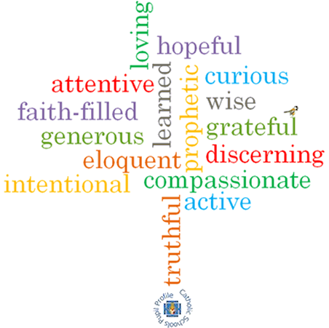

**Topic: Transformation**

**Strand: Pentecost**

**Phase: UKS2**

**Come and See Knowledge Organiser**

**What should I already know?**

The new life of the Easter message is spread through the power of the Holy Spirit

**Big Questions**

How can I transform my energy for the good of others?

How energy can transform?

**Vocabulary I will need to use**

|  |  |
| --- | --- |
| Transformation |  |
| transform |  |
| energy, |  |
| wind, |  |
| fire |  |
| Holy Spirit |  |
| change, |  |
| gift |  |
| Fruits of the Spirit |  |

**Scripture I will hear:**

Galatians : 5: 16-17, 22-23

Luke 24: 13-35

Acts 2: 32-39, 41-42

Acts 22: 6-16

Romans 8: 14-17

**What I will learn**

**Make links** to show how feelings and beliefs about the use of transforming energy affects their behaviour and that of others.

**Compare** their own and other people’s ideas about questions that are difficult to answer about transforming energy and its uses.

**Give reasons** for the actions of Cleopas on the road to Emmaus.

Use a developing religious vocabularyto **give reasons** for religious actions and symbols connected with Pentecost.

**Give reasons** for certain actions of Christians inspired by the Holy Spirit.

**Make links** between scripture and God’s gift of the Holy Spirit and forgiveness.

**Show understanding** ofhow their own and others’ decisions about the use of transforming energy are informed by belief and values.

**Describe and show understanding** of religious sources, beliefs, ideas, feelings and experiences, concerning the conversation of Paul, making links between them.

**Show understanding** of the transforming power of the Holy Spirit and how it shapes the lives of Christians.

**Engage with and respond** to questions about how the belief in the transforming power of the Spirit and the message expressed in Paul’s letter give meaning and purpose to life.

**Virtues**