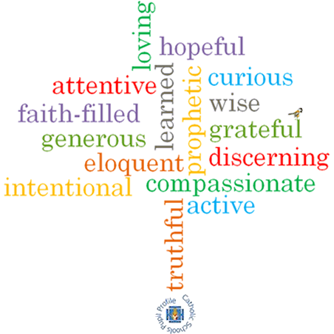

**Strand: Domestic Church**

**Phase: UKS2**

**Topic: Loving**

**Come and See Knowledge Organiser**

**What should I already know?**

That we are made in the image and likeness of God.

**Big Questions**

Does love last forever or does it have limits?

Do you have to earn love?

How can I love people I don’t like?

**Vocabulary I will need to use**

|  |  |
| --- | --- |
| unconditional | No conditions are attached |
| Forgiveness | The action or process of forgiving or being forgiven. |
| Mercy | Compassion or forgiveness shown towards someone. |
| Prodigal | A person who spends money in a reckless way. |
| Parable | A story with a meaning used by Jesus to teach. |
| reconciliation | To forgive and repair a relationship. |

**Scripture I will hear:**

Isaiah 40: 1-5,9-11,28-31

Psalms 23 and 136

Luke 15: 11-32

Matthew 5: 1-12, 44-48

John 15: 9-14

Ephesians 4:26, 31-32

Titus 3: 4-8

**What I will learn**

**Make links** between their beliefs about love, their behaviour and how it affects others.

**Compare** their own and other people’s ideas about questions of unconditional love.

**Make links** between the story of the prodigal son and the Christian’s belief in God’s forgiveness.

**Give reasons** for a Christian’s love and care.

**Describe and show understanding** of the scripture, beliefs, feelings and experience of God’s unconditional love and **make links** between them.

**Show understanding** of how religious belief in God’s unconditional love shapes life.

**Show understanding** of howbeliefs and values affect our love and care of each other.

**Engage with and respond** to questions about loving, in the light of religious teaching.

**Virtues**