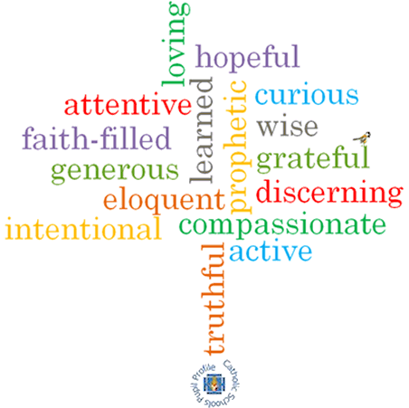

**Topic: Expectations**

**Strand: Advent/Christmas**

**Phase: UKS2**

**Come and See Knowledge Organiser**

**What should I already know?**

Advent is the Church’s season of waiting in joyful hope for the coming of Jesus, the Promised One, at Christmas and at the end of time.

**Big Questions**

What is the difference between *I wish for* and *I expect*?

Why is it good to have high expectations of yourself and others?

What is the role of patience in expectations?

**Vocabulary I will need to use**

|  |  |
| --- | --- |
| expectation | A strong belief that something will happen or be the case. |
| certainty | Firm conviction that something is the case. |
| Advent | A season in the Church’s year. A time of waiting in joyful hope.. |
| Christmas | A Christian festival celebrating Jesus Christ’s birth. |
| Emmanuel | A Hebrew word meaning “God is with us”. |
| Annunciation | The announcement by the Angel Gabriel to Mary that she would be the mother of God’s son, Jesus Christ. |
| Angelus | A prayer of the Catholic Church devoted to Jesus being God’s representative on Earth. The prayer includes the Hail Mary and is traditionally said at morning, noon and sunset. |
| Incarnation | How Jesus Christ embodies God in the flesh on Earth. |

**What I will learn**

**Make links** to show how feelings and beliefs about expectations affect their behaviour and that of others.

**Compare** their own and other peoples’ ideas about questions about expectation that are difficult to answer.

**Make links** between scripture of religious belief in Advent as a time of joyful expectation.

**Give reasons** for certain actions by believers as they wait in joyful expectation of Advent and Christmas.

**Show an understanding** of howtheir own and others’ decisions concerning expectations are informed by beliefs and values.

**Engage with and respond** to questions about expectation in the light of religious teaching.

**Describe and show understanding** of religious sources, beliefs, ideas, feelings and experiences of Advent as a time of joyful expectation of Christmas making links between them.

**Show understanding** of how religious belief in Advent as a time of joyful expectation shapes lives.

**Virtues**

**Scripture I will hear:**

John 1: 14-18

Mark 1: 1-5

Isaiah 35: 1-6, 9, 10

Isaiah 62: 11-12

1 Corinthians 1: 8-9, 1 Corinthians 16: 22

1 Corinthians 16: 13-14