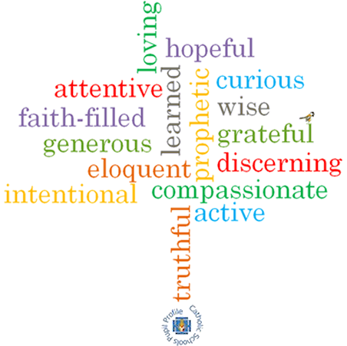

**Topic: Witnesses**

**Strand: Pentecost**

**Phase: UKS2**

**Come and See Knowledge Organiser**

**What should I already know?**

Pentecost is the celebration of the Spirit’s transforming power.

**Big Questions**

Why does it sometimes need courage to be a witness?

How do you know when to speak out?

**Vocabulary I will need to use**

|  |  |
| --- | --- |
| Witness | A person who sees an event take place. |
| Holy Spirit | The third person of the Trinity; God as spiritually active in the world. |
| Martyrs | A person who is killed because of their religious or other beliefs. |
| Courage | the ability to do something that frightens one; bravery. |
| Truth | the quality or state of being true. |
| Inspiration | The process of being mentally stimulated to do or feel something, especially to do something creative. |
| Good News | The message of Jesus concerning the salvation of the faithful. |

**What I will learn?**

**Make links** to show how feelings and beliefs affect their behaviour and that of others when it comes to making a decision about being a witness.

**Compare** their own and other people’s ideas about questions that are difficult to answer about having the courage to witness.

**Make links** between Scripture and belief in the power of the Holy Spirit.

**Give** **reasons** for the witness to Jesus Christ by believers.

**Show how** their own and others’ decisions about witnessing are informed by beliefs and values.

**Show how** understanding of belief in the power of the Holy Spirit shapes lives.

**Describe and show understanding** of Scripture, beliefs, ideas, feelings and experiences of the power of the Holy Spirit in witnessing to the Good News of Jesus Christ and make links between them.

**Virtues**

**Scripture I will hear:**

Luke 24: 44-49

Matthew 28: 16-20

Acts 1: 6-14

Acts 6: 6 – 7:

Acts 16: 11-15

Ephesians 2: 10