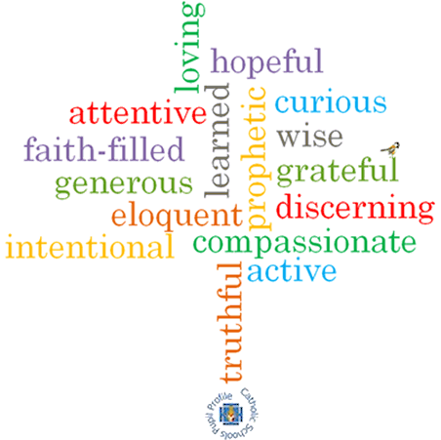

**Topic: Sources**

**Strand: Local Church**

**Phase: UKS2**

**Come and See Knowledge Organiser**

**What should I already know?**

Dioceses continue the work and mission of Jesus, including ecumenism.

**Big Questions**

How our lives are enriched by books?

The wonder of books and how they take a person beyond themselves

**Vocabulary I will need to use**

|  |  |
| --- | --- |
| Poetry | Written work in which the expression of feelings & ideas is given intensity by the use of distinctive style & rhythm. |
| Prose | Written or spoken language in its ordinary form. |
| History | The study of past events. |
| Information | Facts provided or learned about something or someone. |
| Stories | An account of imaginary or real people and events told for entertainment. |
| Bible | Christian scriptures. |
| Old Testament | The first part of the Christian Bible, comprising 39 books of the chief texts of law, history, prophecy & wisdom literature of the ancient people of Israel. |
| New Testament | The second part of the Christian Bible, recording the life & teachings of Jesus Christ and his earliest followers. It includes the four Gospels. |
| genre | A style or category of art, music or literature. |

**What I will learn**

**Compare** their own and other people’s ideas about how books enrich our lives and take us beyond ourselves.

**Make links** between scripture and Christian beliefs.

**Give reasons** for when and how Christians use the Bible.

**Describe** and **show an understanding** of the Bible, the beliefs, ideas, feelings and experiences of the Christian and **make links** between them.

**Show understanding** of how the Bible shapes the lives of Christians.

**Engage** with the question, ‘What is God like?’ or ‘What is Jesus like?’ in the light of religious teaching.

**Show how** their own and others’ decisions are informed by beliefs and values which may be influenced by what they have read.

**Virtues**

**Scripture I will hear:**

Romans 15: 4-6

Bible

Bible references, genre, context