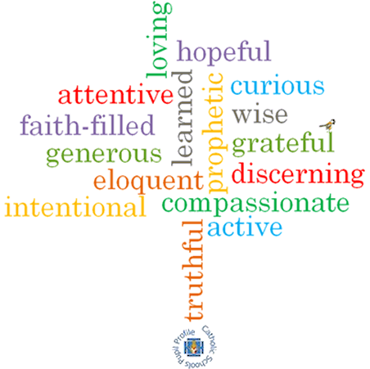

**Topic: Healing**

**Strand: Reconciliation**

**Phase: UKS2**

**Come and See Knowledge Organiser**

**What should I already know?**

God’s rules for living freely and responsibly – the commandments.

**Big Questions**

Why do we care for the sick?

Why do people give time and commitment for caring for others?

What gives a person comfort when they are very ill?

**Vocabulary I will need to use**

|  |  |
| --- | --- |
| Care | The provision of what is necessary for the health, welfare & maintenance and protection of someone or something. |
| Sickness | The state of being ill. |
| Hospice | A home providing care for the sick or terminally ill. |
| Compassion | Sympathetic, pity & concern for the sufferings or misfortunes of others. |
| Sacrament | A religious ceremony or ritual regarded as imparting divine grace. |
| Anointing | To smear or rub with oil, typically as part of a religious ceremony. |
| sin | An immoral act considered to be a transgression against divine law. |
| forgiveness | The action or process of forgiving or being forgiven. |
| parable | A simple story used to illustrate a moral or spiritual lesson, as told by Jesus in the Gospels. |
| Lourdes | A town in South West France, a place of pilgrimage for Roman Catholics as the site of an apparition of the Virgin Mary. |
| Responsibility | The state or fact of having a duty to deal with something or of having control over someone. |

**What I will learn?**

**Make links** to show how feelings and beliefs about sickness and care affects their behaviour and that of others. **Compare** their own and other people’s ideas about questions concerning serious illness and bereavement. Use a developing religious vocabulary to **give reasons** for the religious actions and symbols used in the Sacrament of the Anointing of the Sick. **Give reasons** why Christians care for the sick and the needy.

**Engage and respond** to questions of the experience of sickness and healing in the light of religious teaching. **Show how** their own and others’ decisions about care and compassion towards the sick are informed by beliefs and values. **Describe and show understanding** of religious sources, beliefs, ideas, feelings and experiences concerning the Sacrament of the Anointing of the Sick and **make links** between them. Use religious terms to **show an understanding** of the different liturgies connected to the sacraments offered to the sick and dying. **Show understanding** of how religious belief shapes life, and that caring for those in need is a Christian responsibility.

**Virtues**

**Scripture I will hear:**

Mark 6: 13

Luke 18: 35-43

Luke 10: 30-37

James 5: 14-15