Vocabulary
Blood vessels | Blood vessels are a series of tubes inside your body. They move blood to and from your heart.
Veins | Blood veins that carry blood to the heart.
Arteries | Blood vessels that carry blood away from the heart.
Capillaries | Microscopic blood vessels found in the muscles and lungs.
Oxygenated | To be enriched with oxygen.
Deoxygenated | To be depleted of oxygen.
Atriums | The atriums are the two uppermost chambers of the heart. Blood is pushed from the atriums to the ventricles.
Ventricles | The ventricles are the two lower chambers in the heart.
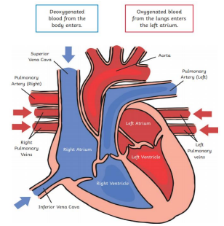
Did you know?
Your heart will beat about 115,000 times each day. Your heart pumps about 2,000 gallons of blood every day.

Sticky knowledge
Blood travels around the body transporting nutrients that have been absorbed into the blood stream from digestion. Blood also carries oxygen around the body which is used to power the body; this use of oxygen to create energy is called respiration.
The heart beats pumping blood around the body and blood vessels carry the blood; arteries carry blood away from the heart; veins carry blood towards the heart; capillaries are tiny blood vessels that connect arteries and veins.
The heart is composed of four chambers: two atria and two ventricles; the aorta is the largest artery in the body and most major arteries branch off from it.
When we exercise, our heart beats more frequently so that the oxygen that is used around the body can be replenished; it returns to a resting heart rate afterwards. Fitter people tend to have lower resting heart rates.

Objectives
-identify and name the main parts of the human circulatory system, and describe the functions of the heart, blood vessels and blood
-recognise the impact of diet, exercise, drugs and lifestyle on the way their bodies function
-describe the ways in which nutrients and water are transported within animals, including humans.

