Vocabulary
Solar system | The solar system consists of the sun and everything that orbits or travels around the sun.
Orbit | The path taken by one body circling around another body. The Earth orbits the sun.
Axis | An imaginary line through the middle of something.
Rotation | A rotation is when a shape is turned around a fixed point.
Planet | There are 8 planets in our solar system. They are: Mercury, Venus, Earth, Mars, Jupiter, Saturn, Uranus and Neptune.
Eclipse | An eclipse occurs when an astronomical object is temporarily obscured. A lunar eclipse is when the Earth moved between the Sun and the Moon, therefore blocking the Sun’s rays from striking the Moon.
Astronomy | The study of astronomy involves all of the objects outside the Earth’s atmosphere.
Objectives
-describe the movement of the Earth, and other planets, relative to the Sun in the solar system
-describe the movement of the Moon relative to the Earth
-describe the Sun, Earth and Moon as approximately spherical bodies
-use the idea of the Earth’s rotation to explain day and night and the apparent movement of the sun across the sky

How long does it take for the Earth to orbit the Sun?
Is Neptune’s orbit around the Sun longer or shorter than Earth’s orbit?
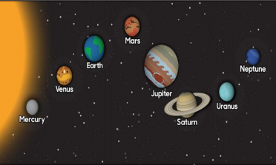
Sticky knowledge
There are eight major planets in our solar system: Mercury, Venus, Earth, Mars, Jupiter, Saturn, Uranus and Neptune.
A star is an exceptionally hot ball of gas, originally made from hydrogen and helium and the Sun is a star.
There is no atmosphere in space, which means that sound has no medium or way to travel to be heard.
The Moon orbits the Sun. Different parts of the Moon are lit up by the Sun, which is why we see a different shape lit up on the Moon as the lunar cycle progresses.
The Moon orbits the Earth roughly every 28 days.
All the planets in the solar system orbit the Sun and that the further away they are from the Sun, the longer their orbit.
The Earth spins around an imaginary line through its centre called an axis. Night and day are the result of the Earth rotating on its axis.

