Vocabulary
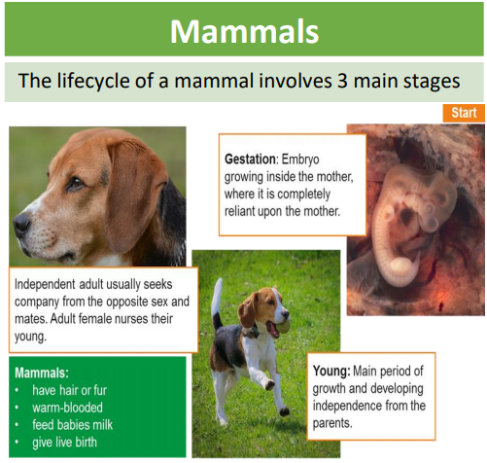
Sticky knowledge
The life cycle of a living thing is a series of stages of development starting with a fertilized egg in animals or a seed in many plants.
In most mammals (e.g. dogs), a fertilised egg develops in the womb into an embryo and is then born and fed on milk before it is weaned onto the food that it is adapted to eat.
In amphibians (e.g. frogs), a fertilised egg develops into an embryo and then hatches into a tadpole; the tadpole develops adult characteristics, metamorphoses into the adult form after which it can reproduce and the cycle can begin again.
In many insects (e.g. butterflies) a fertilized egg develops into wingless feeding form called a larva (caterpillar); the larva feeds then later becomes a pupa (chrysalis) with a protective cocoon; inside this cocoon, the pupa metamorphoses into the adult butterfly after which it can reproduce and the cycle can begin again.
In birds (e.g. robins) a fertilized egg hatches in a nest (a hatchling) and is fed by its parents until it is ready to fly (i.e. becomes a fledgling); it then leaves the nest and grows into an adult after which it can reproduce and the cycle can begin again.

Gestation | The period of time that a mammal carries her offspring, or babies, inside her body before giving birth.
Metamorphosis | A process some animals go through to become adults. It is a series of physical changes.
Embryo | An animal or a plant in its earlies stage of development.
Reproduction | The way different plants and animals make new plants and animal.
Teenager | The age between thirteen and nineteen. It is a time that humans mature quite rapidly.
Toddler | A young child starts to walk and become more independent.
Life cycle | A life cycle shows how things are born, how they grow and how they produce
Jane Goodall is a British scientist who has studied chimpanzees for many years. She is considered to be the world expert on chimpanzees and their behaviour.
Objectives
-describe the differences in the life cycles of a mammal, an amphibian, an insect and a bird
-describe the life process of reproduction in some plants and animals

