Vocabulary
Soluble | Able to be dissolved, especially in water.
Insoluble | Cannot be dissolved, especially in water.
Dissolve | When something solid mixes with a liquid and becomes part of the liquid.
Solution | A solution is made when one substance dissolves into another.
Reversible change | Can be reversed back to its original state.
Irreversible change | Cannot be reversed back to its original state.
Filter | Separates an insoluble solid that is mixed in a liquid.
Oxidisation | The process or result of oxidising or being oxidised. A reaction to oxygen.
Separation | Separate, part and divide mean to break into parts or to keep apart.
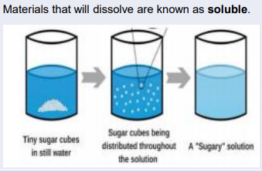
Objectives
-compare and group together everyday materials on the basis of their properties, including their hardness, solubility, transparency, conductivity (electrical and thermal), and response to magnets
-know that some materials will dissolve in liquid to form a solution, and describe how to recover a substance from a solution
-use knowledge of solids, liquids and gases to decide how mixtures might be separated, including through filtering, sieving and evaporating
-give reasons, based on evidence from comparative and fair tests, for the particular uses of everyday materials, including metals, wood and plastic
-demonstrate that dissolving, mixing and changes of state are reversible changes
-explain that some changes result in the formation of new materials, and that this kind of change is not usually reversible, including changes associated with burning and the action of acid on bicarbonate of soda

Sticky knowledge
Mixtures can be separated out by methods like filtering and evaporating.
A change is called irreversible if it cannot be changed back again.
A change is called reversible if it can be changed back again.
Irreversible changes, like burning, cannot be undone. Reversible changes, like melting and dissolving, can be changed back again.
In some solid materials the bonds between particles break when surrounded by a liquid; this allows the liquid to absorb the solid. When this happens, the solid is called a solute, the liquid is called a solvent and the result is a solution.
When a solid does dissolve in a liquid it is described as being soluble in that solvent (e.g. sugar in water); when it cannot it is insoluble (e.g. sand in water).
Filtering allows solids and liquids to be separated and sieving allows solids made up of different sized parts to be separated.
when a solvent is evaporated from a solution, the original solute is left behind; the remaining solid will often form crystals.

Is toasting bread an example of reversible or irreversible changes?

