Vocabulary
Circuit | A complete and closed path where a circulating current can flow.
Conductor | A material or device which allows heat or electricity to carry through.
Insulator | Any material that electricity cannot pass through or along.
Static electricity | A stationary (still) electric charge, usually produced by friction, which causes sparks or crackling or the attraction of dust or hair.
Appliance | An electrical appliance is a device that uses electricity to perform a function.
Cells | An electrical cell is a device that is used to generate electricity.
Objectives
-identify common appliances that run on electricity
-construct a simple series electrical circuit, identifying and naming its basic parts, including cells, wires, bulbs, switches and buzzers
-identify whether or not a lamp will light in a simple series circuit, based on whether or not the lamp is part of a complete loop with a battery
-recognise that a switch opens and closes a circuit and associate this with whether or not a lamp lights in a simple series circuit
-recognise some common conductors and insulators, and associate metals with being good conductors

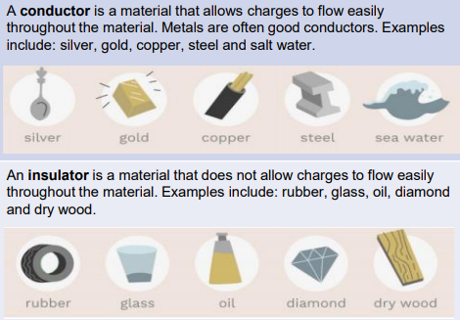
Sticky knowledge
Electrical current flows well through some materials, called electrical conductors, and poorly through other materials, called electrical insulators.
Current electricity is the flow of charged particles called electrons around a circuit.
Metals are good electrical conductors.
More than one cell lined up to work together is called a battery.
Electrical current can flow if there is a complete circuit.
Wires – which contain a conductor inside them, usually made of metal – can allow electrical current to flow around a circuit.
When electrical current flows through a circuit, components within that circuit – such as buzzers which make a noise and bulbs which emit light – begin to work.
A switch functions by completing or breaking a complete circuit.

In which circuit will the bulb light up?
