Vocabulary
Matter | Any solid, liquid or gas that exists in the universe
Solid | Substance that stays the same shape whether in a container or not
Liquid | Substance that can flow and take on the shape of a container
Gas | Substance that has no fixed shape, like oxygen
Temperature | How hot or cold something is, normally measured in degrees Celsius (°C)
Evaporation | The process of liquid heating and changing into a gas
Condensation | The process of a gas cooling and changing into a liquid
Water cycle | The process of water being recycled over and over again
Water vapour | This is water that takes the form of a gas. When water is boiled, it evaporates into a water vapour
Sticky knowledge
Things are made up of a material in one of three states of matter: solid, liquid or gas.
Materials and objects are made of particles that are organised differently in different states.
Materials can change state when temperature changes.
When solids turn into liquids, this is called melting. When liquids turn to solids, this is called freezing.
When liquids turn into gases, this is called evaporation. When gases turn into liquid, this is called condensation.
The melting point of water is 0º C and the boiling point of water is 100º C.
Evaporation occurs when water turns into water vapour. This happens very quickly when the water is hot, like in a kettle, but it can also happen slowly, like a puddle evaporating in the warm air
Condensation is when water vapour is cooled down and turns into water. The water vapour in the air cools when it touches the cold surface. For example, water droplets forming inside windows.

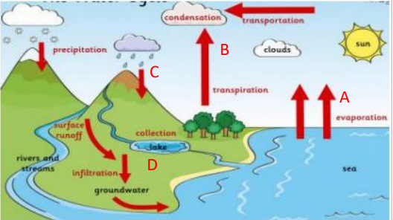
Objectives
-compare and group materials together, according to whether they are solids, liquids or gases
-observe that some materials change state when they are heated or cooled, and measure or research the temperature at which this happens in degrees Celsius (°C)
-identify the part played by evaporation and condensation in the water cycle and associate the rate of evaporation with temperature

Is this image representing the particles of a solid, liquid or a gas? 