Vocabulary
Opaque | Opaque materials do not let any light through. They block the light e.g. wood.
Translucent | Translucent materials let some light through, but they scatter the light in all directions so you cannot see clearly through them e.g. tissue paper.
Transparent | Transparent materials let light through them in straight lines so that you can see clearly through them e.g. glass.
Light source | The main light source for Earth is the Sun. Some other luminous objects give out light, for example, torches, candles and lamps.
Reflection | A reflection occurs when a ray of light hits a surface and bounces off.
Shadows | A shadow is formed when an object blocks out the light. The object must be opaque or translucent to make a shadow.
Sticky knowledge
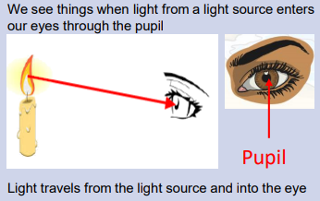
We need light to see things and darkness is the absence of light.
Light travels in straight lines.
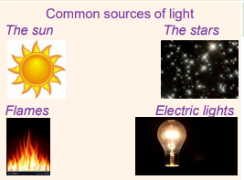
Everything we see is either a light source or something that is reflecting light from a light source into our eyes.
The Sun is a light source, but the Moon is not. The Moon is reflecting light from the Sun.

Objectives
-recognise that they need light in order to see things and that dark is the absence of light
-notice that light is reflected from surfaces
-recognise that light from the sun can be dangerous and that there are ways to protect their eyes
- recognise that shadows are formed when the light from a light source is blocked by a solid object
-find patterns in the way that the size of shadows change

Is a mirror a light source?
Can a transparent object make a shadow?
The Moon is a light source. True or false?
