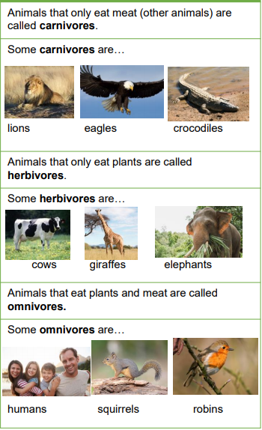

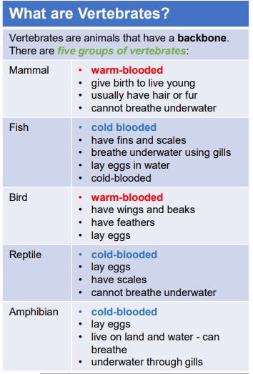

Objectives

-identify and name a variety of common animals including fish, amphibians, reptiles, birds and mammals

-identify and name a variety of common animals that are carnivores, herbivores and omnivores

-describe and compare the structure of a variety of common animals (fish, amphibians, reptiles, birds and mammals, including pets)

-identify, name, draw and label the basic parts of the human body and say which part of the body is associated with each sense.

