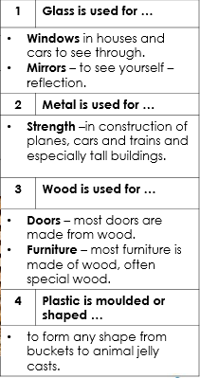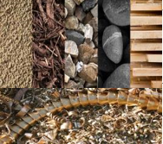

|  |  |
| --- | --- |
| Vocabulary | |
| Materials | What something is made of e.g. wood, plastic, metal. |
| Wood | The material that comes from a tree. |
| Plastic | A man-made material that can be shapes or moulded to any shape. |
| Metal | A tough and strong material which can be heated and shaped into anything. |
| Liquid | Liquids can flow and take on the shape of their container. |
| See through | Able to see through it easily. |
| Bend | A bendy material is one that can be twisted and is flexible. |
| Waterproof | A material that does not allow water or liquid through. |
| Smooth | An even surface without lumps or bumps. |
| Rough | Has an uneven surface. |

Which material would you use to make a jumper?

Wood or wool

Objectives

-distinguish between an object and the material from which it is made

-identify and name a variety of everyday materials, including wood, plastic, glass, metal, water, and rock

-describe the simple physical properties of a variety of everyday materials

-compare and group together a variety of everyday materials on the basis of their simple physical properties

Sticky knowledge