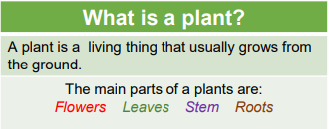

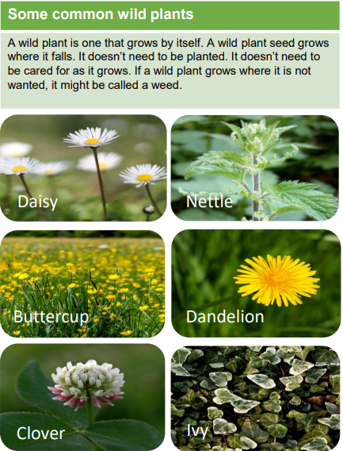

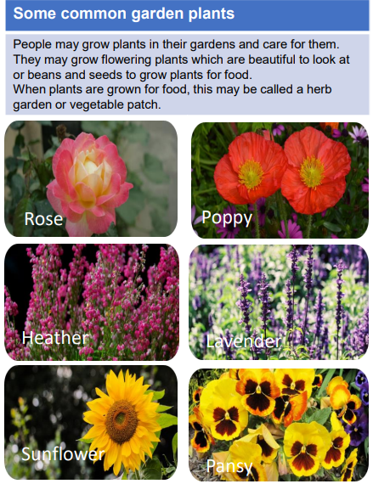

Sticky knowledge

|  |  |
| --- | --- |
| Vocabulary | |
| Flower | Part of a plant that attracts insects and birds. |
| Stem | Part of a plant which helps support it and keep it upright. |
| Root | Part of a plant which takes in water and nutrients from the soil. |
| Leaf | Part of a plant which absorbs sunlight which is used by the plant to make food. |
| Seed | The part of a flowering plant that can grow into a new plant. |
| Blossom | Blossom is the flower that comes before the fruit. For example, apple blossom comes before the apple starts to grow. |
| Deciduous | A tree that sheds its leaves during autumn. |
| Evergreen | A tree that keeps its leaves all year round. |

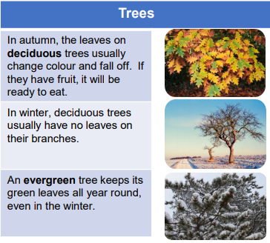

Objectives

-identify and name a variety of common wild and garden plants, including deciduous and evergreen trees

-identify and describe the basic structure of a variety of common flowering plants, including trees